Daydream Believer

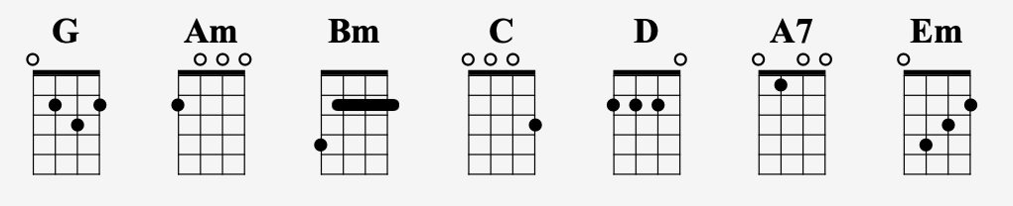
[Intro]

| G | D | G | D |

[Verse 1]
G Am Bm C
Oh, I could hide 'neath the wings Of the bluebird as she sings
G Em A7 D7
The six o'clock alarm would never ring
G Am Bm C
But it rings and I rise Wipe the sleep out of my eyes
Gx2 Em x2 Amx2 D7 x2 G x8
The shaving razor's cold and it stings

[Chorus]

C x2 D x2 Bm x4 C x2 D x2 Em x2 C x2
Cheer up sleepy Jean. Oh, what can it mean to a

G x4 C x4 G x2 Em x2 A7 x4 D7 x4
Daydream believer and a ho-ome coming quee--een

[Verse 2]
G Am Bm C
You once thought of me. As a white knight on his steed
G Em A7 D7
Now you know how happy I can be
G Am Bm C
Oh, and our good times start and end Without dollar one to spend
Gx2 Em x2 Amx2 D7 x2 G x8
But how much baby do we really need

[Chorus]

[Interlude]
| G | D | G | D |

Chorus and interlude to close

Save The Last Dance For Me
C
You can dance, every dance with the guy, who gave you the eye
G
Let him hold you tight.You can smile, every smile for the man, who held your hand
C
'Neath the pale moonlight
Chorus
F C
But don't forget who's taking you home, and in whose arms you're gonna be,
G7 C
So darlin' Save the last dance for me.

Verse 2
C G
Oh I know, that the music is fine, like sparkling wine Go and have your fun.
G7 C
Laugh and sing, but while we're apart, don't give your heart to anyone

Chorus
F C
But don't forget who's taking you home, and in whose arms you're gonna be,
G7 C
So darlin' Save the last dance for me.

Bridge
G C
Baby don't you know I love you so? Can't you feel it when we touch?
G C
never, never let you go I love you oh so much

Verse 3
C G
You can dance, go and carry on, till the night is gone and it's time to go
G7 C
If he asks, if you're all alone, can he take you home You must tell him no

Chorus (Twice)
F C
But don't forget who's taking you home, and in whose arms you're gonna be,
G7 C
So darlin' Save the last dance for me.

The Lion Sleeps Tonight

(Drumming to start ) sing first line with no chords

C x4 F x4 C x4 G x4
Ee – oo – ee –oo-a- ee-oo –ee-oo - a- ee –um – um –oweh

Chorus
C x4 F x4 C x4 G x4
Wimoweh, wimoweh, Wimoweh………………………………….

Verse 1

C x4 F x4 C x4 G x4
In the jungle, the mighty jungle The lion sleeps tonight
C x4 F x4 C x4 G x4
In the jungle, the quiet jungle The lion sleeps tonight

Chorus

Verse 2
C x4 F x4 C x4 G x4
Near the village, the peaceful village The lion sleeps tonight
C x4 F x4 C x4 G x4
Near the village, the quiet village The lion sleeps tonight

Chorus
C x4 F x4 C x4 G x4
Hush my darling, don't fear my darling The lion sleeps tonight (twice)

Nice To Meet You – Miles Smith
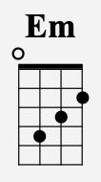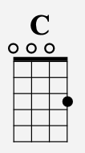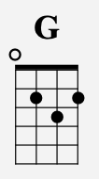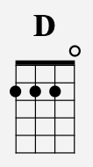

Em C G
Lonely in this crowd, I sit alone, oh
Em C G
One more drink away from heading home, oh

[Pre-Chorus]
Em C G D
Oh, I could feel the night slipping by Oh, a-way from me
Em C G D
And, oh, she caught my eye through the light Then she came right up to me

[Chorus]
She said,
Em C G D
"Oh, hi, nice to meet you Tonight, maybe we could go dance, get up off our feet"
Em C G D
She said, "This life ain't forever. One song, here together. Then let's play it on repeat"
Em C
We could dance, we could dance all night .We could dance till the morning light
G D
Lеt's forget about our worries and the wild world outsidе
Em C G D
"Oh, hi, nice to meet you Tonight, maybe we could go dance, get up off our feet"
N.C.
We could dance, we could dance all night

Instrumental
Em C G D

[Verse 2]
Em C G
She took my hand and led me through the dark, oh
Em C G
She said, "Feel the beat, forget that broken heart", oh.
[Pre-Chorus]
Em C G D
Oh, I could feel the night slipping by Oh, a-way from me
Em C G D
And, oh, she caught my eye through the light Then she came right up to me

[Chorus]
Happy Together

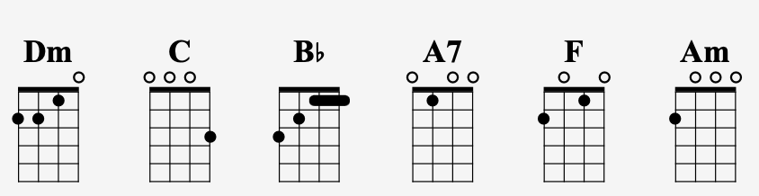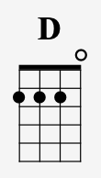

Dm C
Imagine me and you, I do, I think about you day and night, it's only right
Bb A7
To think about the girl you love and hold her tight. So happy together
Dm C
If I should call you up, invest a dime, and you say you belong to me, and ease my mind
Bb A7
Imagine how the world could be, so very fine. So happy together

Chorus
D Am D F
I can't see me lovin' nobody but you, For all my life
D Am D F
When you're with me, baby, the skies'll be blue, For all my life

Verse 2
Dm C
Me and you, and you and me. No matter how they toss the dice, it had to be
Bb A7
The only one for me is you, and you for me. So happy together

Chorus
D Am D F
I can't see me lovin' nobody but you, For all my life
D Am D F
When you're with me, baby, the skies'll be blue, For all my life

Verse 3
Dm C
Me and you, and you and me. No matter how they toss the dice, it had to be
Bb A7
The only one for me is you, and you for me. So happy together

Chorus (Twice)
D Am D F
I can't see me lovin' nobody but you, For all my life
D Am D F
When you're with me, baby, the skies'll be blue, For all my life
Take Me Home, Country Roads
by John Denver

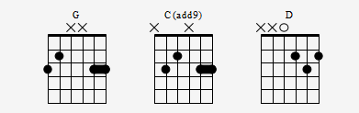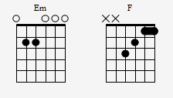
Capo 2

[Verse]

G Em D C G
Almost Heaven, West Virginia, Blue Ridge Mountains, Shenandoah River.
G Em D C
Life is old there, older than the trees, younger than the mountains, blowin
G
like a breeze.

[Chorus]

G D Em C
Country Roads, take me home, to the place I belong
G D C G
West Virginia, mountain mama, take me home, country roads.

[Verse 2]

G Em D C
All my memories gather round her, miner's lady, stranger to blue
G
water.
G Em D C
Dark and dusty, painted on the sky, misty taste of moonshine, teardrop in my
G
eye.

[ Bridge ]

Em D G
I hear her voice in the morning hours she calls me
C G D
the radio reminds me of my home far away.
Em F C G
And driving down the road I get a feeling that I should have been home
D D7
yesterday, yesterday.

[ Chorus & End]

Hold On Tight To Your Dream – ELO
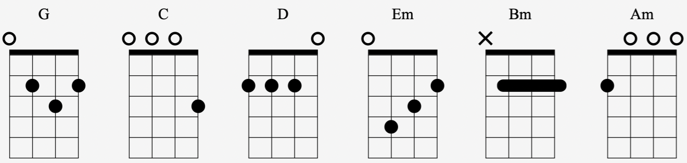
Verse 1
G D G C G
Hold on tight to your dream Hold on tight to your dream.
C G C G
When you see your ship go sailing When you feel your heart is breaking
G D G
Hold on tight to your dream
G D G C G
It's a long time to be gone. Time just rolls on and on
C G C G
When you need a shoulder to cry on When you get so sick of trying
G D G
Just hold on tight to your dream

[Chorus]
Em Bm Em Bm
When you get so down that you can't get up
Am D Am D
And you want so much but you're all out of luck
Em Bm Em Bm
When you're so downhearted and misunderstood
Am Bm C D
Just over and over and over you could
Verse 2
G D G C G
Accroches-toi a ton reve. Accroches-toi a ton reve
C G C G
Quand tu vois ton bateau partir. Quand tu sents -- ton coeur se briser
G D G
Accroches-toi a ton reve.

Repeat chorus
Verse 3
G D G C G
Hold on tight to your dream. Hold on tight to your dream
C G C G
When you see the shadows falling. When you hear that cold wind calling
G D G
Hold on tight to your dream.
G D G
Hold on tight to your dream
G D G
Yeah, hold on tight…….. To your dream

